UNIT II – ELECTROCHEMISTRY

Electrochemistry
Electrochemistry is a branch of chemistry which deals with the chemical reactions brought about by electric current or electric current produced by chemical reactions.
Electrochemical Reaction:
Redox (oxidation-reduction) reactions in which electrons are transferred from a donor (reducing agent) to an acceptor (oxidant).
Reactions take place by movement of electrons or ions across the interface (Electrical Double layer) of electrode and electrolyte.
Redox Reactions
Reactions in which oxidation and reduction takes place simultaneously are known as redox reaction.
Oxidation describes the loss of electrons by an electron donor (reducing agent)
Eg., Zn(s) Zn ²⁺ (aq) + 2 e –

Reduction describes the gain of electrons by electron acceptor (oxidizing agent)
Ex., Cu²⁺(aq) + 2 e ⁻ Cu (s)
Each of the reaction is known as half- reaction and an electrode with electrolyte is called half-cell. Both half-reactions must always go side by side to sustain the electrochemical reaction.
The net reaction: Zn (s) + Cu²⁺ (aq) Zn²⁺ (aq) + Cu (s)
Based on the type of reaction occurring in the cell, cells are classified into two types
1. Electrolytic cell - Electrical energy is converted into chemical energy
2. Electro chemical cell- Chemical energy is converted into electrical energy

Differences between electrolytic cell and electro chemical cell
Electrolytic cell | Electro chemical cell
Electrical energy is converted into chemical energy | Chemical energy is converted into electrical energy
Anode carries positive charge and cathode carries negative charge | Anode carries negative charge and cathode carries positive charge
Here electrons are supplied to the cell from the external battery | Electrons are drawn from the cell
Amount of the electricity passed during electrolysis is measured by coulometer | emf produced in the cell is measured by potentiometer

ELECTROCHEMICAL CELLS (or) Galvanic cells:
Consists of two half-cells joined by a salt bridge or some other path (porous membrane) that allows ions to pass between the two sides in order to maintain electro neutrality. Oxidation occurs at one half cell while reduction takes place at the other half cell.
ELECTROCHEMICAL CELLS

Liquid junction potential occurs when two solutions of different concentrations/compositions are in contact with each other through porous membrane. It is due to formation of an electrical double layer of positive and negative charges at the junction of the two solutions as the ions diffuse through membranes (Helmholtz Electrical Double Layer).

Salt bridge: Contains a solution of a salt (KCl or KNO₃ or NH₄NO₃) that literally serves as a bridge to complete the electric circuit, maintain electro neutrality of electrolyte and minimize the liquid junction potential. For precise measurements of potential, a salt bridge is used.

Fundamental components of electrochemical cell
1. Anode: oxidation half-reaction takes place;
eg. Zn Zn ²⁺ +2 e – (oxidation)
Oxidation of metal releases metal ions into the solution of oxidation half-cell, leaving behind the electron at the surface of the metal electrode.
2. Cathode: reduction half-reaction occurs;
eg. Cu²⁺ + 2e ⁻ Cu (reduction)
Movement of metal ions from the solution to the electrode to gain electrons in reduction half cell leads to accumulation of positive charge at the surface of the electrode.
3. Electrolyte: Internal conducting environment that allows ions to migrate between both half cells so as to preserve electro neutrality
4. External circuit: Two half-cells are joined together by wire through which electrons flow.
5. Salt bridge/porous membrane: Serves as a bridge to complete the electric circuit and maintain electro neutrality in the electrolyte.

REVERSIBLE AND IRREVERSIBLE CELLS

Reversible Cells: A cell works reversibly in the thermodynamic conditions. Eg. Daniel cell, Secondary batteries, Rechargeable batteries.

The cell is reversible if it satisfies all the following conditions:
(i) If applied emf is equal to derived emf then the net reaction is zero
(ii) If applied emf is infinitesimally smaller than the derived emf then the cell should act as electrochemical cell (forward reaction)
(iii) If applied emf is infinitesimally greater than the derived emf then the cell should act as electrolytic cell (reverse reaction)
Irreversible Cell: Cells which do not obey the (above) conditions of thermodynamic reversibility are called irreversible cells. If one of the products escapes from the cell then that cell cannot be made reversible by applying an external current. Eg. Zinc-Silver cell, Primary cells
Zinc-Silver cell reaction:
Anode: Zn + H₂SO₄ ▬▬► ZnSO₄ + H₂ ↑
Cathode: 2Ag⁺ + 2e⁻ ▬▬► 2Ag
When two electrodes are connected from outside, zinc dissolves liberating hydrogen gas. Since one of the product hydrogen escapes, the cell reaction cannot be reversed when connected to an external EMF. The cell does not obey the conditions of reversibility and is called irreversible cell.
CONCENTRATION CELLS
- Electricity is produced due to the movement of ion by concentration gradient.
- The transport of ions due to concentration gradient of the electrolyte at both half-cells is accompanied by a fall in free energy.
- The loss in free energy produces electrical energy
- electrolyte (concentrated) electrolyte (dilute)
- No net chemical reaction
- Concentration cell is made up of two half-cells having identical electrodes, identical electrolyte, except that the concentrations of reactive ions at two electrodes are different. The half cells may be joined by a salt bridge.

Eg1. –Ag AgNO₃ (C1) salt bridge of std.NH₄NO₃ AgNO₃ (C2) Ag⁺

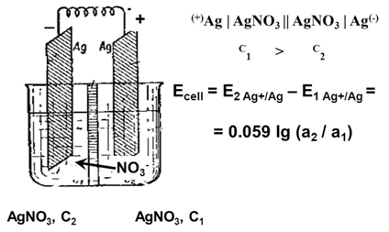

E° for a concentration cell is always zero, since this would be the potential of a cell in which the electro active species are at unit activity in both compartment
0.0592V
E_{cell} = --------------------------- Log [C2/C1]
n
Emf of an Electrochemical Cell
The potential difference which causes the flow of current from the electrode of higher potential to electrode of lower potential. It is the algebraic sum of the single electrode potentials provided the proper sign are given according to actual reaction taking place on the electrodes.

Nernst equation for electrochemical cell
ECell = E right-Eleft, (or) Ecell = Ecathode –Eanode

Measurement of emf:
emf of the cell can be measured by potentiometer-using Poggendorff’s compensation principle (wheatstone's bridge). Voltmeter cannot be used to determine accurate value of emf because during measurement a part of cell current is drawn which causes change in the emf.

ELECTRODE POTENTIAL
Potential difference sets up between the metal and solution at equilibrium is known as electrode potential of a metal which is constant. Each electrode (half-cell) of an electrochemical cell has associated with an electrode-solution potential difference whose magnitude depends on the nature of the particular electrode reaction and on the concentrations of the dissolved ions according to Nernst equation.
Oxidation Potential: When a metal M is dipped in its salt solution, one of the following reactions occurs depending on the metal:
Positive metal ions pass into the solution: M → Mn⁺ + ne⁻ (oxidation)
(e.g.) When Zn rod is dipped in ZnSO₄ solution, Zn goes into solution as Zn²⁺
The electrons attach to Zn rod, giving it a negative charge. The negative charge on the rod attracts positive ions from solution. Thus a double layer of ions is formed close to the rod.
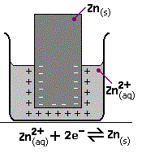
Reduction Potential: Positive ions from the solution deposit over the metal.
Mn⁺ + ne⁻ → M (reduction)
When Cu rod is dipped in CuSO₄ solution, Cu⁺² ions from the solution deposit on metal rod. They attract negative ions from solution. Thus a double layer of ions is formed close to the metal rod. This is called Helmholtz double layer.
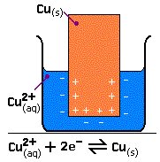
As a result a potential difference is set up between the metal and the solution. The equilibrium value of the potential difference is known as electrode potential.

Factors affecting electrode potential:
(i) Nature of the metal, (ii) Temperature, (iii) Concentration of metal ions in the solution

Singe Electrode Potential (E):
It is a measure of the tendency of the metal electrode to lose or gain electrons, when it is in contact with its own salt solution. It is developed due to the formation of a double layer around the metal rod.

Standard Electrode Potential (E⁰):
It is a measure of the tendency of the metal electrode to lose or gain electrons, when it is in contact with its own salt solution of 1M strength at 25°C.

NERNST EQUATION FOR ELECTRODE POTENTIAL

Let us consider the following redox reaction in a reversible cell:

M^{n+}(aq) + ne⁻ M(s)

A + B C + D

The above reversible reaction the free energy change and its equilibrium constant (k) are related as

ΔG = -RT ln k + RT ln [Product]/[Reactant] --------------- (1)

ΔG = -RT ln k, so

ΔG = ΔG° + RT ln [Product]/[Reactant] ----------------- (2)

ΔG° = standard free energy change and equation (2) is known as Van’t Hoff isotherm.

In any cell reaction, the decreasing free energy change is producing electrical energy.

We know that, ΔG = - nFE
ΔG° = -nFE°

where n = number of electrons present
E = emf of the cell
F = Faraday (96500) coulombs

therefore equation (2) becomes

-nFE = -nFE° + RT ln [C][D]/[A][B]

-nFE = -nFE° + RT ln [M]/[M^{n+}] ------------------ (3)

divided by –nF on both sides in equation (3) we get

E = E⁰ – RT/nF ln [M]/[M ^{n+}]

The activity of metal [M] = 1

E = E⁰ – RT/nF ln [1]/[M ^{n+}]

E = E⁰ + RT/nF ln [M ^{n+}] --------------------- (4)

E = E⁰ + 2.303 RT/nF log [M ^{n+}] --------------------- (5)

Apply the values R, T & F (R = 8.314 J/K/mole, F = 96500 Coulombs, T = 273+25 = 298 K)

Equation (5) becomes

E = E⁰_{red} + 0.0591/n log [M ^{n+}] ---------------------- (6)

In general, E = E⁰ + 0.0591/n log [C]

Similarly for oxidation potential

E = E⁰_{oxi} - 0.0591/n log [M ^{n+}] ----------------------- (7)

Equations (6) and (7) are known as Nernst equation for a reversible cell.

Applications:
(i) To calculate electrode potential of unknown metal
(ii) Application of emf series
(iii) Corrosion tendency of metals can be predicted.

PROBLEM BASED ON NERNST EQUATION
Calculate the reduction potential of lead electrode in contact with a solution of 0.015M Pb²⁺ ions. (E⁰ = -0.13 volt).
GIVEN,
Std Oxidation potential is given as
Pb²⁺ + 2 e⁻ → Pb; E⁰ = -0.13V and concentration of Pb²⁺ = 0.015M
Solution:
The Nernst equation for reduction potential is
E = E⁰red + 0.0591/n log(Pb²⁺)
E = -0.13 +0.0591/ 2 log (0.015)
E = -0.1839V
Oxidation potential of Pb = -0.1839V

MEASUREMENT OF ELECTRODE POTENTIALS

- It is impossible to determine the value of a single electrode potential.
- But we can always measure the potential difference between two electrodes using a potentiometer, by combining the two electrodes to form a cell.
- For this purpose we use reference electrode.
- Standard hydrogen electrode is called primary reference electrode. Calomel electrode is called secondary reference electrode.

Reference Electrodes: Act as one of the half cell of the electrochemical cell to measure the electrode potential of an electrode as a cell.

Requisites for reference electrodes
- Electrodes should be reversible and obey the Nernst equation with respect to some ions in the electrolyte
- Easy to prepare and maintain
- Potential should be stable, its potential should return to the equilibrium potential after small currents are passed through the electrode.
PRIMARY REFERENCE ELECTRODE:

STANDARD HYDROGEN ELECTRODE (SHE) or NORMAL HYDROGEN ELECTRODE (NHE)

Its potential has been arbitrarily fixed at zero

It is represented as Pt | ½ H₂(g) | H⁺ (aq) ||

Construction: Hydrogen gas at 1 atm pressure is allowed to bubble over a platinum electrode having a specially treated (platinised) surface which is dipped in a 1M H⁺ solution at 25°
Platinum electrode catalyzes the reaction, H⁺ + e– ½ H₂ (g)
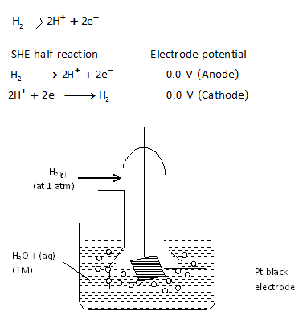

Limitation: The SHE is seldom used because
- It is more difficult to get pure H₂
- It is difficult to set up and transport.
- The pressure of H₂ is to be kept 1 atm all the time.
- The electrode potential changes with barometric pressure.
- A large volume of test solution is required.
- It cannot be used in solutions of redox systems.
- The solution may poison platinum surface. So we use a secondary reference electrode.

SECONDARY (AUXILIARY) REFERENCE ELECTRODES:
Potential is kept constant by maintaining stable concentration of ions by taking the saturated solution of the insoluble salt of the ion.

CALOMEL ELECTRODE
Construction:
It consists of a glass tube containing Hg at the bottom; above that Hg₂Cl₂ (calomel) paste is placed; above this saturated solution of KCl is taken. The Pt wire is sealed in a glass tube and its bottom is in contact with Hg as shown in the figure. The side tube is used for making electrical contact as salt bridge.

The electrode potential of saturated calomel electrode = 0.2422 V
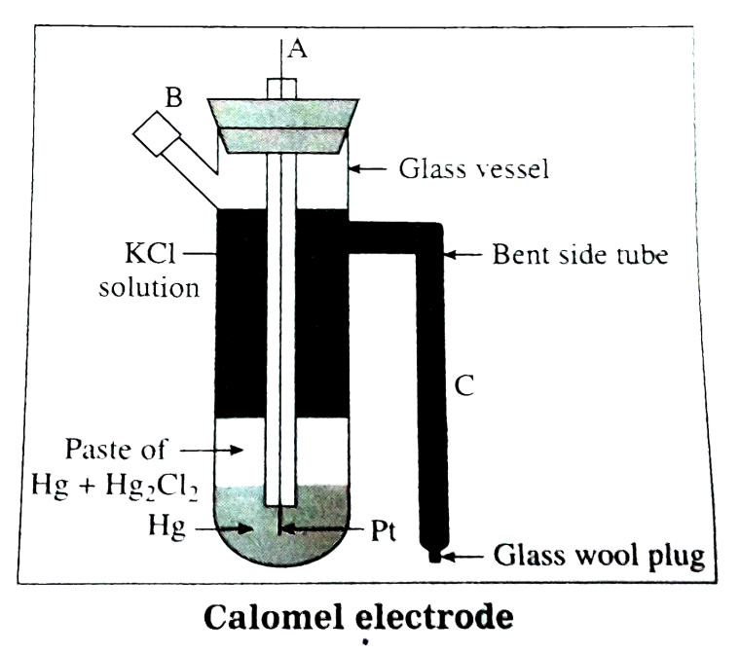
Cell Represented as Pt| Hg | Hg₂Cl₂ | KCl (saturated)
Cell Reaction:
If this electrode acts as anode, reaction is 2 Hg(l) Hg₂²⁺ + 2e⁻
If this electrode acts as cathode, reaction is Hg₂²⁺ + 2e⁻ 2 Hg(l)

The potential of this electrode depends on the concentration of Cl⁻ and it decreases as the concentration of Cl– increases. Its reduction potential is given by E(sat.) = + 0.2422 V, E(0.1N.) = + 0.3338 V and E(1N.) = + 0.280 V, it is called respectively as normal (NCE) and Saturated Calomel Electrode (SCE)

Advantages of Calomel Electrode:
1. Easy to set up.
2. Easily transportable
3. Long shelf life
4. Reproducibility of emf
5. Low temperature coefficient
6. Electrode can be used in a variety of solutions.
7. Eº value is accurately known

ION SENSITIVE ELECTRODE:
Ion sensitive electrodes have the ability to respond only to a specific ion and develop a potential ignoring other ions in the solution.
The types (classification) of ion-sensitive electrode:
1) Glass membrane electrodes
2) Solid state electrode
3) Pungor or precipitate electrodes
4) Liquid – liquid electrode

GLASS ELECTRODE (Measurement of pH using Glass Electrode)
Construction:
A glass electrode consists of thin – walled bulb (the glass is a special type having low melting point and high electrical conductivity) containing a Pt wire in 0.1 M HCl.
The glass electrode is represented as Pt, 0.1 M HCl / glass
The thin walled glass bulb called glass membrane functions as an ion exchange resin, and equilibrium is established between the Na⁺ ions of glass and H⁺ ions in solution and its emf is given by the expression

E_{G}= E⁰_{G} - 0.0595 log [H⁺] (or) E_{G}= E⁰_{G} + 0.0595 p[H⁺]

Measurement of pH:
The glass electrode is dipped in the given solution. This system is connected to saturated calomel electrode as in the figure. The emf of the resulting cell is measured using a potentiometer. From the emf, the pH of the solution is calculated as below:
E_{cell} = E_{right} – E_{left}

Ecell = E_{calomel} – E_{glass}

E_{calomel} = potential of saturated calomel electrode = 0.2422 V

E = Eº_{G}lass − 0.0591pH − 0.2422

∴pH = Eº_{Glass}−0.2422 − E / 0.0591

And hence this is how pH is determined by applying Nernst's equation to glass electrode.
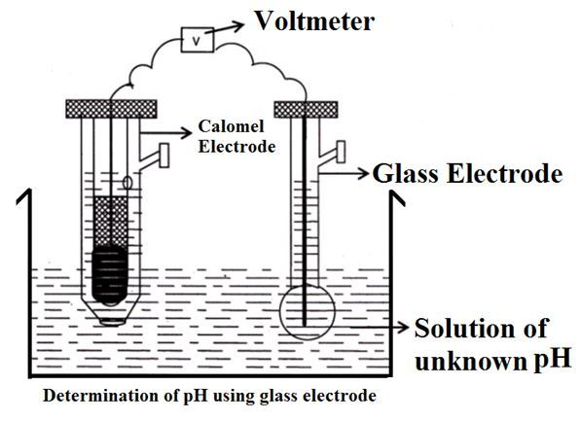
Advantages of Glass Electrode:
i) It is easily constructed and used
ii) results are accurate
iii) electrode is not easily poisoned
iv) equilibrium is quickly attained
v) can be used in strong oxidizing solutions, coloured solutions and in presence of metal ions
vi) using special glass electrode, pH can be measured from 0 to 12.
vii) It is used in chemical, industrial, biological and agricultural laboratories.

Disadvantages or Limitations:
i) Glass has high resistance, so special electronic potentiometer must be used.
ii) It cannot be used in highly alkaline solutions, in pure ethanol or in acetic acid. If the solution pH is more than 12, glass membrane is affected by cations.
Applications of Ion-sensitive electrode:
i) To determine ions like H⁺, K⁺, Li⁺, etc.
ii) To determine hardness of water (Ca⁺² and Mg⁺² ions)
iii) To determine concentration of F⁻, CN⁻ etc.
iv) To determine concentration of a gas using gas-sensing electrodes.
v) To determine pH of a solution using H⁺ ion sensitive electrode.

ELECTROCTREMICAL SERIES (E.M.F SERIES)
An arrangement in which the standard electrode reduction potential of different metals are arranged in increasing order on the basis of hydrogen scale is known as emf series.

Electrode | Electrode Reaction | E⁰ Volts | Nature
Li⁺/Li | Li + e- Li | -3.01 | Anodic  H₂ reference  Cathodic
Mg ²⁺/Mg | Mg ²⁺ + 2e⁻ Mg | -2.37 | Anodic  H₂ reference  Cathodic
Pb²⁺/Pb | Pb²⁺+ 2e⁻ Pb | -1.12 | Anodic  H₂ reference  Cathodic
Zn²⁺/Zn | Zn²⁺ + 2e⁻ Zn | -0.76 | Anodic  H₂ reference  Cathodic
Fe²⁺/Fe | Fe²⁺ + 2e⁻ Fe | -0.44 | Anodic  H₂ reference  Cathodic
Sn²⁺/Sn | Sn²⁺ + 2e⁻ Sn | -0.136 | Anodic  H₂ reference  Cathodic
H⁺/H₂ | 2 H⁺ + 2e⁻ H₂ | 0.00 | Anodic  H₂ reference  Cathodic
Cu²⁺/Cu | Cu²⁺+ 2e⁻ Cu | +0.34 | Anodic  H₂ reference  Cathodic
Ag⁺/Ag | Ag⁺ + e⁻ Ag | +0.80 | Anodic  H₂ reference  Cathodic
Pt⁴⁺/Pt | Pt⁴⁺ + 4e⁻ Pt | +0.86 | Anodic  H₂ reference  Cathodic
Au⁺/Au | Au⁺ + e⁻ Au | +1.50 | Anodic  H₂ reference  Cathodic

Application of electrochemical series:
1. Calculation of standard emf of a cell (E⁰)
Standard emf of a cell is calculated based on emf series
E ⁰ _{cell} = E⁰_{R.H.E} - E⁰_{LH.E}

2. Relative ease of oxidation or reduction
The metals on the top are more active, easily ionized into solution and they are good electron donor. i.e The metals which are present above hydrogen in the emf series (-E⁰ Value) will undergo oxidation. Eg: Zn E ⁰ _{Zn} = -0.76 V
The metals present hydrogen in the emf series (+E⁰ Value) will undergo reduction. Eg: Cu
E ⁰ _{Cu} = + 0.80 V
3. Calculation of equilibrium constant (K)
Equilibrium constant ‘K’ can be calculated using formula
∆G⁰ = -RT ln K
∆G⁰ = - RT 2.303 log K
Log K = - ∆G ⁰ = nFE⁰
2.303 RT 2.303 RT
4. Calculation of standard free energy change (∆G⁰)
Standard free energy change can be calculated based on the emf series
∆G ⁰ = - nFE⁰

5. Displacement of one metal by another (Replacement tendency)
Metals present above hydrogen in the emf series will displace the metals present below in the emf series form its solution. (i.e The metals which are more active will displace less active ion from the solution of its salt)
Example: Zn + CuSO₄ ZnSO₄ + Cu²⁺
E⁰_{Zn}= - 0.76V and E⁰_{Cu} = + 0.34 V

6. Liberation of Hydrogen
The metal with –ve potential will displace H₂ from an acid solution i.e., active metals are attacked by acids (Zinc reacts with hydrogen but not in Ag. Why?)

The metals present above hydrogen will displace hydrogen from an acid
Zn + H₂SO₄ ZnSO₄ + H₂
E⁰_{Zn}= -0.76V

Metals present below hydrogen do not displace hydrogen from an acid.
Ag + H₂SO₄ No Reaction
E⁰_{Ag} = +0.80 V

7. Spontaneity of a reaction
If E⁰value is +ve then the reaction is spontaneous
If E⁰value is -ve then the reaction is non-spontaneous

POTENTIOMETRIC TITRATIONS

Potentiometric titration is a volumetric method in which the changes in the emf between two electrodes (referent and indicator electrode) on the addition of titrant of known concentration (titrant) to a solution of unknown (analyte).

The indicator electrodes is reversible with respect to one of the ions of analyte taking part in the titration reaction but does not take part in the reaction. They are inert electrode made up of Pt or Au.

During the course of the titration, the concentration of active ion in the analyte changes thereby electrode potential of indicator electrode changes.

Types of potentiometric titration for the determination of analytes in solutions include acid-base, redox, precipitation, and complexometric.

Redox Titration: Fe²⁺ against dichromate

The concentration of an ion such as Fe²⁺ can be found by titrating with a strong oxidizing agent such as KMnO₄ (Mn⁷⁺) or K₂Cr₂O₇ (Cr⁶⁺)

The titration is carried out in one side of a cell whose other half is a reference electrode: Calomel electrode, Pt| Hg | Hg²⁺ (aq) | KCl ||

Cell configuration: Pt(s)| Hg⁺ (aq)|Hg₂Cl₂ (s) | KCl || Fe³⁺(aq)| Fe²⁺(aq)| Pt(s)

E = E_{Indictor} - E_{SCE}

E_{indicator} (E_{Fe}³⁺_{/Fe}²⁺) = E⁰ (Fe³⁺/ Fe²⁺) + 0 .0591 log Fe³⁺/Fe²⁺
where E⁰ Fe³⁺/Fe²⁺ = 0.77V

Initially the left cell contains only Fe²⁺. As the titrant is added, the ferrous ion is oxidized to Fe³⁺ according to the reaction.

K2Cr2O7 + FeSO4+7H2 SO4 Cr2 (SO4)3 + 3 Fe2 (SO4)3 +7H2 O + K2 SO4

Once the first drop of Cr⁶⁺ (K₂Cr₂O₇) titrant has been added, the potential of the indicator electrode is controlled by the ratio of oxidized and reduced iron which causes the potential to rise as more iron becomes oxidized. Near the end-point the ratio changes very rapidly since a small quantity of of added Mn⁷⁺ or Cr⁶⁺ removes considerable proportion of the few remaining Fe²⁺ ions.

When the equivalence point is reached, the Fe²⁺ will have been totally consumed and the potential will then be controlled by the concentration ratio of cell couple Cr⁶⁺ / Cr³⁺

The end point is found not by measuring a particular cell voltage, but by finding what volume of titrant gives the steepest part of the curve.

A titration curve has a characteristic sigmoid curve. The part of the curve that has the maximum change marks the equivalence point of the titration.

The first derivative, ΔE/ΔV, is the slope of the curve, and the endpoint occurs at the volume, V, where ΔE/ΔV has the maximum value.

STORAGE DEVICES
BATTERY:
A battery is a device which converts chemical energy into electrical energy. In other words, a battery is an arrangement of several electrochemical cells is connected in series, which can be used as a source of direct electric current. That is, it contains several anodes and cathodes.
Example - The ordinary 6 volt Lead storage battery is a combination of three 2 volt cells connected in series.
A useful battery should fulfil the following requirements
1. It should be light and compact for easy transport.
2. It should have long life both when it is being used and when it is not used.
3. The voltage of the battery should not vary appreciably during its use.
Classification of batteries
Batteries are broadly classified into the following three categories. They are
1. Primary battery (or) Primary cells
2. Secondary battery (or) Secondary cells
3. Flow battery (or) Fuel cells

Primary battery
The battery in which cell reaction is not reversible is primary battery. i.e. The electrode reaction cannot be reversed by passing an external electrical energy. In the primary batteries the reaction occurs only once and after use over a period of time battery becomes dead and cannot be reused again. Therefore, they are not chargeable.
Examples: Dry cells, Alkaline battery, Mercury cells.

Secondary battery
The battery in which cell reaction is reversible is secondary battery. i.e. The electrode reaction can be reversed by passing an external electrical energy. Secondary batteries are one which can be recharged and reused repeatedly. These are called storage cells or accumulators.
Examples: Lead acid storage cells, Nickel Cadmium cells, Lithium battery.

Flow batteries
In these batteries, the materials (reactants, products and electrolytes) continuously pass through the cell, which is simply an electrochemical cell that converts chemical energy of the fuels directly into electrical energy without combustion.

Fuel + Oxygen Oxidation products + Electricity

Example: Hydrogen – Oxygen fuel cell

Differences between primary and secondary batteries

S.No | Primary batteries | Secondary batteries
1 | Irreversible batteries | Reversible batteries
2 | It can be used only once | It can be used, recharged and reused
3 | They are cheap | They are costlier
4 | Initial cost is low | Initial cost is very high

ALKALINE BATTERY
- An alkaline battery is an improved form of the dry cell.
- In this cell, the electrolyte is a concentrated solution of KOH (35 – 50%).
- As the electrolyte in this cell is an alkali, it is called alkaline battery.

Anode: Zinc
Cathode: Carbon rod / Graphite
Electrolyte: Powdered KOH, MnO₂ in the form of paste

Cell representation: Zn / KOH / MnO₂ / Carbon (graphite)

The outer container is made of zinc sheet which acts as anode and a mixture of manganese dioxide and carbon acts as the cathode. The electrolyte in this cell is potassium hydroxide (KOH). A paste of KOH and zinc chloride (ZnCl₂) is filled in the space between the electrodes. The alkaline cell derives its power from the oxidation of zinc anode and the reduction of manganese dioxide cathode. The emf of this cell is 1.5 volt.

Cell reaction
Anode: Zn + 2OH⁻ Zn(OH)₂ + 2e⁻
Cathode: 2MnO₂ + 2H₂O + 2e⁻ 2MnO.OH + 2OH⁻
---------------------------------------------------------------------------------------------------
Overall cell reaction: Zn + 2MnO₂ + 2H₂O Zn(OH)₂ + 2MnO.OH
---------------------------------------------------------------------------------------------------
The alkaline battery is called a heavy duty battery, because it sustains heavy use and has a longer self life than zinc – carbon cell.

Advantages
1. As potassium hydroxide is used as an electrolyte, zinc does not readily dissolves.
2. Since there is no corrosion of zinc, the life of alkaline battery will be longer.
3. Even in hot weather, it performs better than other types of batteries.
4. Its output capacity is high.

Disadvantages
More expensive than common dry cells

Uses
Alkaline batteries are used in camera exposure controls, calculators, watches, etc.,

SECONDARY BATTERIES

LEAD – ACID BATTERY (STORAGE CELL)

Storage cell
This cell can operate both as a voltaic cell and as an electrolytic cell.
As a voltaic cell, it supplies electrical energy (discharging) and becomes ‘run down’.
As an electrolytic cell, it receives electrical energy (recharging) and stores it.
Example: The common example for a storage cell is a Lead – acid storage cell.

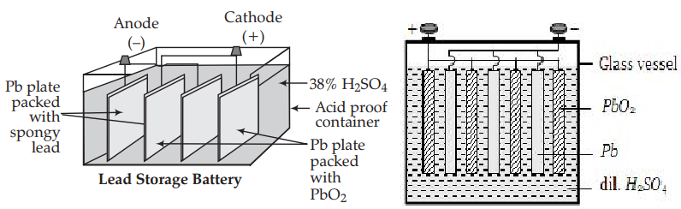

Description
The Lead – acid storage battery consists of three to six identical cells joined together in series. Each of its cells has a lead anode (Pb) and lead dioxide (PbO₂) cathode. A number of lead plates (anodes ‘–ve’ plates) are connected in parallel and a number of lead dioxide plates (cathodes ‘+ve’ plates) are also connected in parallel. The lead plates fits in between the lead dioxide plates. The anodes and cathodes are separated from the adjacent ones by insulators like strips of wood (or) rubber (or) glass fiber sheets. The entire combination is then immersed in 38% of sulphuric acid (H₂SO₄) having a density of 1.3 g / mL.

Anode: Lead (Pb) plate
Cathode: Lead dioxide (PbO₂)
Electrolyte: dil. Sulphuric acid (dil.H₂SO₄)
The cell may be represented as, Pb / PbSO₄ // H₂SO₄ / PbO₂ / Pb

A single cell generates 2 volt and six such cells in the battery produces a total of 12 volt.

Working
When the storage cell is operating as voltaic cell (ie., for supplying electrical energy), it is said to be discharging.

Discharging
At anode
Lead is oxidized to Pb²⁺ ions, which further combines with SO₄²⁻ ions forms insoluble PbSO4.
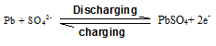
At cathode
The electrons released from the anode flows to dioxide electrode. Here PbO₂ gains electrons to form Pb²⁺ ions. In other words, lead undergoes reduction at the cathode from oxidation state +4 to +2. The Pb²⁺ ions then combine with SO₄²⁻ ions.

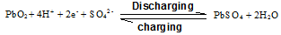
Overall cell reaction:

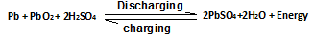
Recharging
When both anode and cathode become covered with PbSO₄, the cell stops its functioning. Recharging is done by applying a voltage across the electrodes that is slightly higher than the voltage (2V), the current will flow in the opposite direction, that is the battery can deliver. As the result lead sulphate gives lead and oxide. Pb is deposited on anode and PbO₂ is deposited on the cathode.

Net reaction during charging is:
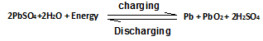
Maintenance
If the lead – acid storage batteries are properly maintained in the following ways, they can function for long periods.
1. Avoid over discharging of the battery.
2. Maintain the electrolyte at the proper level by adding water (whenever required).
3. Keep the battery clean.
4. Avoid overheating the battery

Advantages
1. It is made easily.
2. It provides a large burst of current to the engine starter motor.
3. Reliable and has long life.
4. The self – discharging rate is low when compared to other rechargeable batteries.
5. It is effective at low temperatures

Disadvantages
1. These batteries tend to slowly self – discharge. It will be difficult to start a car when idle for several weeks.
2. When the temperature is very low, sulphuric acid becomes viscous, thereby inhibiting the flow of ions between the plates.
3. Corrosive and toxic substances are used.
4. Recycling of this battery causes environmental hazards.

Uses
1. Lead acid storage cell is used mainly in automobiles such as cars, buses, etc.
2. It is also used in gas engine ignition, telephone exchanges, hospitals, etc.,
3. As it is rechargeable, it is used in UPS (Uninterrupted Power Supply) a power system which maintains current flow without even a momentary break in the event of current failure.

NICKEL – CADMIUM CELL (or) NICAD battery
- Nickel – Cadmium cell is another important secondary battery. It is also a rechargeable battery.

Anode: Cadmium rod
Cathode: NiO₂ coated on nickel rod
Electrolyte: Potassium hydroxide (KOH)

The cell may be represented as, Cd / Cd(OH)₂ // KOH / NiO₂ / Ni
It produces a voltage of about 1.4 V
Working (during discharging)
During the operation of an NICAD battery, cadmium is oxidized to Cd²⁺ ions and insoluble Cd(OH)₂ is formed

At anode
Cadmium is oxidized to give Cd²⁺ ions and electrons. The Cd²⁺ ions react with OH⁻ ions to give insoluble Cd(OH)₂.
At cathode
Electrons are gained by NiO₂. Ni undergoes reduction from Ni⁴⁺ to Ni²⁺. This Ni²⁺ ions contribute with OH⁻ ions to give Ni(OH)₂.

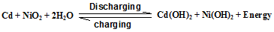
Recharging
The recharging process is similar to lead – acid storage battery. Recharging is done by applying a voltage across the electrodes that is slightly greater than the voltage (1.4V), the current will flow in the opposite direction, that is the electrode reaction gets reversed. As a result, cadmium is deposited on anode and NiO₂ is deposited on the cathode.

The overall cell reaction during discharging and charging is,
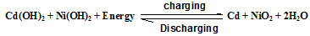
Advantages
1. It is comparatively smaller and lighter.
2. It has a longer life than a lead – acid storage battery.
3. It can be packed in a sealed container like a dry cell.
4. It does not use corrosive materials.

Disadvantages
1. It is more expensive than lead – acid storage battery.
2. Cadmium discarded in the environment, enters the human body and cause health problems.

Uses
1. NICAD cells are commonly used in calculators, transistors, electronic camera flashes, rechargeable flash lights, etc.
2. The good low temperature performance has lead to wide use of NICAD batteries in aircraft and space satellite power systems.

LITHIUM BATTERY
- Lithium metal is attractive as a battery anode material because of its light weight, high voltage and good conductivity.
- It is regarded as the battery of the future.
- Lithium battery is a solid state battery, since a solid electrolyte is used instead of a liquid or a paste.

Description
It has a Lithium anode at one end, a TiS₂ (Titanium sulphide) cathode at another end and a solid electrolyte. A solid electrolyte, normally a conductive polymer is packed in between the two electrolytes. The conductive polymer (solid electrolyte) permits the passage of ions but not the electrons.

Anode: Li
Cathode: TiS₂
Electrolyte: Conductive polymer (solid)
The cell may be represented as, Li / polymer / TiS₂
The cell is rechargeable and produces a cell voltage of 3 V

Working (Discharging)
Cell reaction: Li + TiS₂ Li ⁺ + TiS₂⁻

and Li⁺ + TiS₂⁻ Li Ti S₂

Recharging
The Lithium battery can be recharged by supplying an external current, that is slightly greater than the voltage (3 V), which drives the Lithium ions back to the anode.

Li Ti S₂ Li⁺ + TiS₂⁻

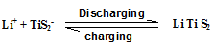
Several other types of secondary lithium batteries are also known; the Li / MnO₂, Li / V₂O₅, Li / MoO₂ and Li / Cr₃O₈ are some among these.

Advantages
The lithium battery is considered to be the cell of the future because,
1. Lithium is a light weight metal, only 7 g required for produce one mole of electrons.
2. Its cell voltage is high, 3 V.
3. Lithium has the most negative Eº value (-3.01 V) and therefore generates a higher voltage than the other types of cells.
4. The energy output of a lithium cell is 2 – 4 times better than that of conventional zinc anode batteries.
5. Many of the lithium cells will perform over a temperature range of 40 – 70 °C.
6. All the constituents of the battery are solids and hence there is no risk of leakage from the battery.
7. It can be made into conventional shapes and sizes.

Disadvantages
1. Lithium battery is more expensive than other batteries.
2. Early versions of a lithium battery had a short life and variable outputs.

Uses
Button sized lithium batteries are used in calculators, watches, cameras, mobile phones, laptop computers, etc.,

FUEL CELL: It is a device in which the chemical energy of the fuel hydrogen is directly converted into electricity without combustion.

Fuel + Oxygen Oxidation Product + Electricity
Eg: H₂-O₂ fuel cells

H₂-O₂ FUEL CELL:
- It consists of two porous electrodes anode and cathode.
- Two porous electrodes – Made of compressed carbon containing a catalyst like Pt/Pd.
- In between two electrodes an electrolytic solution 25% KOH or NaOH filled.
- When H₂ is bubbled through the anode compartment, where it is oxidized.
- The O₂ is bubbled at the cathode compartment where it is reduced.

Anode : | Hydrogen
Cathode : | Oxygen ( oxidizer)
Electrolyte : | 25% KOH or NaOH

Working At Anode:
- The hydrogen gas is bubbled through the anode compartment
- It undergoes oxidation by liberation of electrons and combines with OH⁻ to form H₂O
- Cell reaction: 2H₂ + 4OH⁻ 4H₂O + 4e⁻

At Cathode:
- The oxygen is bubbled through the cathode compartment.
- The electron produced at the anode pass through the external wire to the cathode where it is absorbed by O₂ and H₂O to produce OH⁻ ions.
- Cell reaction: O₂ + 2H₂O + 4e⁻ 4OH⁻

Over all cell reactions
At Anode: 2H₂ + 4OH⁻ 4H₂O + 4e⁻
At Cathode: O₂ + 2H₂O + 4e⁻ 4OH⁻
---------------------------------------------------------------
Over all cell reaction: 2H₂+ O₂ 2H₂O
---------------------------------------------------------------

The standard emf of the hydrogen-oxygen fuel cell is 1.23 V

Merits:
i. High efficiency (more than 75%)
ii. No unwanted noise and less maintenance.
iii. No pollution – emits only water vapour
iv. No need to change electrode often.

Limitations:
- H₂ gas is explosive
- It is very expensive to be carried out
- H₂ is a gas, it is difficult to compress into liquid form

Uses:
i. Used in military vehicles and space vehicles.
ii. H₂ – O₂ fuel cell, the product is water, so no need of fuel because fuel is water.

MICROBIAL FUEL CELLS:
- A microbial fuel cell (MFC) is a device that converts chemical energy to electrical energy by the action of microorganisms.
- These electrochemical cells are constructed using either a bioanode and/or a biocathode (catalytic reaction of micro organisms)
- Bio-electro chemical system
- Mimics bacterial interaction
- Based on redox reaction
- Harness the natural metabolism of microbes to produce electricity
- Bacteria covert substance into electrons
- Electrons run through the circuit to generate power

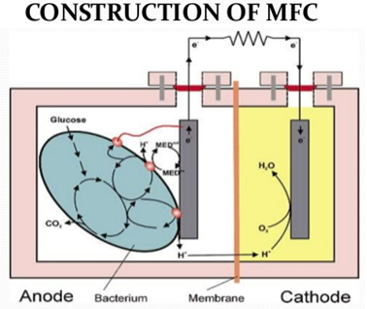
Components
Anode
Cathode
Exchange membrane
Substrate
Electrical circuit
Microbes

- The electrons from the cathode combine with dissolved oxygen and the H+ ions to form pure H₂O.
- The H+ ions flow through the semi-permeable membrane to the cathode. This process is driven by the electro-chemical gradient resulting from the high concentration of H⁺ ions near the anode.
- The electrons flow up from the anode, through a wire, and onto the cathode. While flowing through the wire, an electrical current is generated that can be used to perform work.
- The electrons flow from the bacteria to the anode, sometimes assisted by a mediator molecule.
- When microorganisms consume a substance such as sugar in aerobic conditions, they produce carbon dioxide and water. However, when oxygen is not present, they produce carbon dioxide, hydrons (hydrogen ions), and electrons, as described below
C₁₂H₂₂O₁₁ + 13H₂O → 12CO₂ + 48H⁺ + 48e⁻
- Microbial fuel cells use inorganic mediators to tap into the electron transport chain of cells and channel electrons produced.
- Potential mediators include natural red, methylene blue, thionine, and resorufin
- Organisms capable of producing an electric current are termed exoelectrogens. In order to turn this current into usable electricity, exoelectrogens have to be accommodated in a fuel cell.
Applications:
- Used in Waste water treatment
- Power generation
- Bio-Sensors

Advantages of MFC
- Generation of energy out of bio waste / organic matter
- Direct conversion of substrate energy to electricity
- Omission of gas treatment
- Aeration
- Bioremediation of toxic compounds
Limitations of MFC
- Low power density
- High initial cost
- Activation losses
- Bacterial metabolic losses

SUPER CAPACITOR
- It is a high capacity capacitor.
- They store 10 to 100 times more energy per unit volume and deliver charge much faster than batteries.
- Super capacitor use electrostatic double layer capacitance

Design of super capacitor:
It consists of two electrode separated by an ion permeable membrane and dipped in an electrolyte containing positive and negative ion connecting both the electrodes.
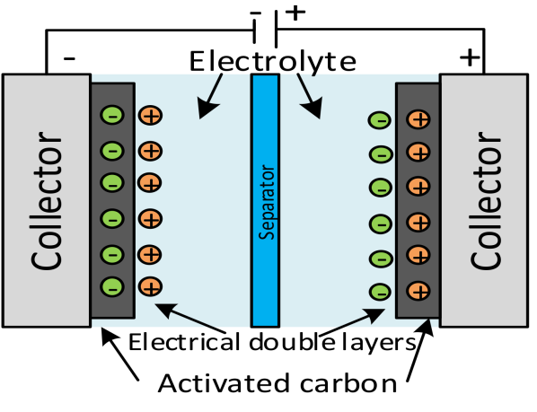
Working
- When the electrodes are connected to the power source, ions in the electrolyte form electric double layer (Helmholtz electric double layer) of opposite polarity to the electrodes polarity, creating an electric fields between them.
- The positively polarized electrodes will have a layer of negative ions at the electrode / electrolyte interface.
- Similarly the negatively polarized electrode will have a layer of positive ions t the electrode / electrolyte inter face.
- The electric field polarizes the dielectric
- It stores more electrical energy at an electrode / electrolyte interface

Advantages
- It is highly safe
- Life time is very high (10 – 20 years)
- Can be cycled millions of time
- It can be charge in seconds
- It provides high power density and high load currents
- Its performance is excellent even at low temperature.
Disadvantages
- Cost per watt is high
- It cannot be used as source for continuous power supply
- It should be connected in series for high voltage
- High self-discharge
Applications
- Voltage stabilization in start/stop system
- Energy harvesting
- Kitchen appliances
- Wind energy
- Utility meters
- Consumer electronics
- Remote power for sensors, LEDs, switches
- Energy efficiency and frequency regulation

-------------------------------------------------------------------------------------------------------------

MCQ

1. The process in which substance gains electrons is called
- oxidation
- hydrogenation
- sublimation
- reduction

2. An electrolytic cell uses electrical energy to drive
- chemical reaction
- physical reaction
- no reaction
- biochemical reaction
3. An electrochemical cell is also called
- battery cell
- galvanic cell
- cell
- chargeable cell

4. Electrochemical cells convert which of these into electrical energy?
- mechanical energy
- potential energy
- kinetic energy
- chemical energy

5. The electrolyte among the following is
- NaOH
- urea
- glucose
- benzene

6. Electrolytes convert electricity in
- solid state
- liquid state
- gaseous state
- plasma state

7. Galvanic cells are also named as
- electrolytic cells
- battery cells
- Daniel cells
- John cells

8. By losing one or two electrons the atoms of metal are
- oxidized
- reduced
- hydrogenated
- sublimated
9. Voltaic cells generate electricity by
- spontaneous redox reaction
- non spontaneous redox reaction
- sublimation reaction
- thermochemical reaction

10. Reduction reaction means ________
- a process of adding oxygen
- a process of removing hydrogen
- a process of adding electron
- a process of removing electrons

11. Which substance is oxidizing agent ?
- a substance donates hydrogen or accepts oxygen
- a substance donates oxygen or accepts hydrogen
- a substance experience oxidation
- a substance donates electron

12. Which substance is called reducing agent?
- a substance donates hydrogen or accepts oxygen
- a substance accepts hydrogen or donates oxygen
- a substance expereince reduction
- a substance gains electron

13. Which of the following statement is true?
- there is always reduction occur of oxidizing agent
- there is always oxidation occur of reducing agent
- oxidation and reduction are supplementary processes
- Given three statements are wrong.

14. Which of the following cell is different?
- Daniel cell
- lead storage cell
- laclanche cell
- electrolytic cell

15. Select correct option for the statements given with reference to electrochemical cell (where T = true and F = false)
(i) in external circuit e flow from cathode to anode.
(ii) in solution electricity conducted through ions.
(iii) in external circuit electric current flow from anode to cathode.
(iv) anions move from anode to cathode through salt bridge.

- TFTF
- FTFF
- FFFT
- FTTF

16. Which of the following has been universally accepted as a reference electrode at all temperatures and has been assigned a value of zero volt?
- Pt electrode
- Cu electrode
- graphite electrode
- std.H₂ electrode

17. H₂ gas is not liberated when the following metal is added to dil.HCl
- Ag
- Zn
- Mg
- Sn

18. As Lead storage battery is charged
a) Lead dioxide dissolves
b) sulphuric acid is regenerated
c) lead electrode becomes coated with lead sulphate
d) the concentration of sulphuric acid decreases

19. What gets deposited on the plates of a discharged lead-acid battery?
a) PbO₂
b) Pb₂O₄
c) Pb
d) PbSO₄

20. Which of the following is the advantage of alkaline battery?
a) High energy density
b) Good discharge characteristics over a wide range of temperature
c) The specific gravity of electrolyte remains the same
d) Cheap raw materials are used

21. A fuel cell is used to convert chemical energy into ____________
a) Mechanical energy
b) Solar energy
c) Electrical energy
d) Potential energy

22. Select the incorrect statement from the following option.
a) Fuel cells have high efficiency
b) The emission levels of fuel cells are far below the permissible limits
c) Fuel cells are modular
d) The noise levels of fuel cells are high

23. Which of the following is not an example of a fuel cell?
a) Hydrogen-oxygen cell
b) Methyl-oxygen-alcohol cell
c) Propane-oxygen cell
d) Hexanone-oxygen cell

24. The standard emf of the hydrogen-oxygen fuel cell is ____________
a) 1.23 V
b) 2.54 V
c) 3.96 V
d) 0.58 V

25. Hydrogen-oxygen fuel cell can produce drinking water of potable quality.
a) True
b) False

----------------------------------------------------------------------------------------------------------------

1. Match the following
Column I | Column II
(i) Calmoel electrode | gas electrode.
(ii) Glass electrode | reference electrode
(iii) Hydrogen electrode | redox electrode
(iv) Quinhydrone electrode | membrane electrode

Answer
Column I | Column II
i) Calmoel electrode | reference electrode
(ii) Glass electrode | membrane electrode
(iii) Hydrogen electrode | gas electrode
(iv) Quinhydrone electrode | redox electrode

2. Match the following
Column I | Column II
(i) Li-ion battery | (a) Pacemakers
(ii) Mercury button cell | (b) Fuel cell
(iii) Lead storage battery | (c) Cell phone
(iv) H2-O2 cell | (d) Inverter

Answer
Column I | Column II
(i) Li-ion battery | (c) Cell phone
(ii) Mercury button cell | (a) Pacemakers
(iii) Lead storage battery | (d) Inverter
(iv) H₂-O₂ cell | (b) Fuel cell

3. Match the following
Column I | Column II
Electrolytic cell | concentration cell
△G⁰ | converts electric energy to chemical energy
Eº = 0 | maintaining electro neutrality
Salt bridge | −nFE⁰_{cell}

Answer
Column I | Column II
Electrolytic cell | converts electric energy to chemical energy
△G⁰ | −nFE⁰_{cell}
Eº = 0 | concentration cell
Salt bridge | maintaining electro neutrality

4. Match the following
Column I | Column II
(i) Cadmium rod- anode, NiO₂ coated on nickel rod- cathode, KOH- electrolyte | (a) Lithium-ion battery
(ii) Zinc-anode, Carbon rod / Graphite- cathode, Powdered KOH, MnO₂ in the form of paste- electrolyte | (b) NICAD battery
(iii) Spongy lead anode, lead plate bearing PbO₂ | (c) Alkaline battery
(iv) Li-anode, TiS₂- cathode, Conductive polymer (solid)- electrolyte | (d) Lead storage battery

Answer
Column I | Column II
(i) Cadmium rod- anode, NiO₂ coated on nickel rod- cathode, KOH- electrolyte | (b) NICAD battery
(ii) Zinc-anode, Carbon rod / Graphite- cathode, Powdered KOH, MnO₂ in the form of paste- electrolyte | (c) Alkaline battery
(iii) Spongy lead anode, lead plate bearing PbO₂ | (d) Lead storage battery
(iv) Li-anode, TiS₂- cathode, Conductive polymer (solid)- electrolyte | (a) Lithium-ion battery

